## CHANDIGARH UNIVERSITY

## UNIVERSITY INSTITUTE OF NGINEERING

**DEPARTMENT OF COMPUTER SCIENCE & ENGINEERING**



|  |  |
| --- | --- |
| **Submitted By: Submitted To:**  Vivek Kumar(21BCS8129) Er. Himanshi(13362) | |
| **Subject Name** | Web and Mobile Security Lab |
| **Subject Code** | 20CSP-338 |
| **Branch** | Computer Science and Engineering |
| **Semester** | 5th |

**Experiment - 1**

**Student Name: Vivek Kumar UID: 21BCS8129**

**Branch: BE-CSE(LEET) Section/Group: WM-20BCS-616/A**

**Semester: 5th Date of Performance: 16/08/2022**

**Subject Name: Web and Mobile Security Lab Subject Code: 20CSP-338**

**1. Aim/Overview of the practical:**

Identity HTTP packet on Wireshark.

**2. Task to be done/ Which logistics used:**

Data Manipulation using the Pandas and Seaborn library.

**3. Requirements (For programming-based labs):**

To analyze HTTP traffic. We use Wireshark to analyze the HTTP traffic.

**4. Steps for experiment/practical/Code:**

1. **Clearing Browser History**

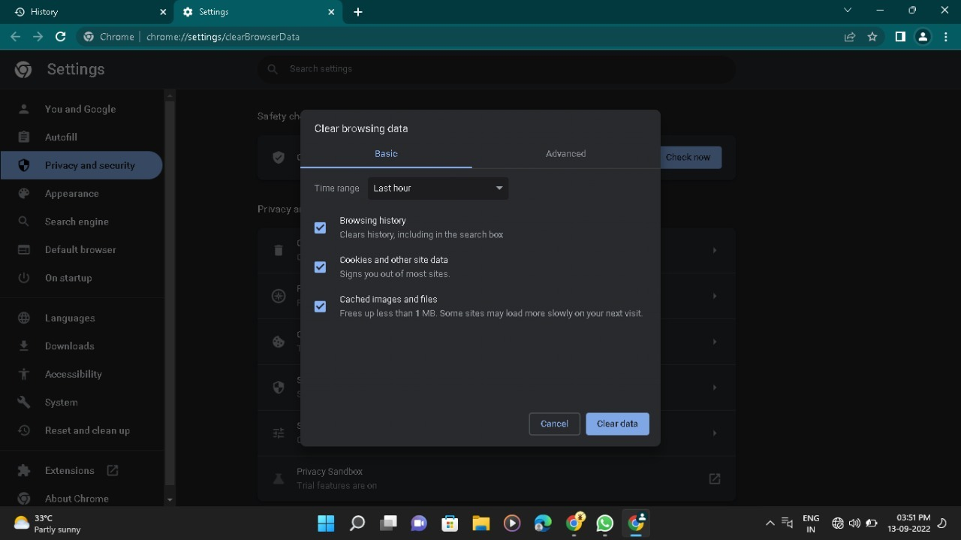

1. **Selecting the network:**

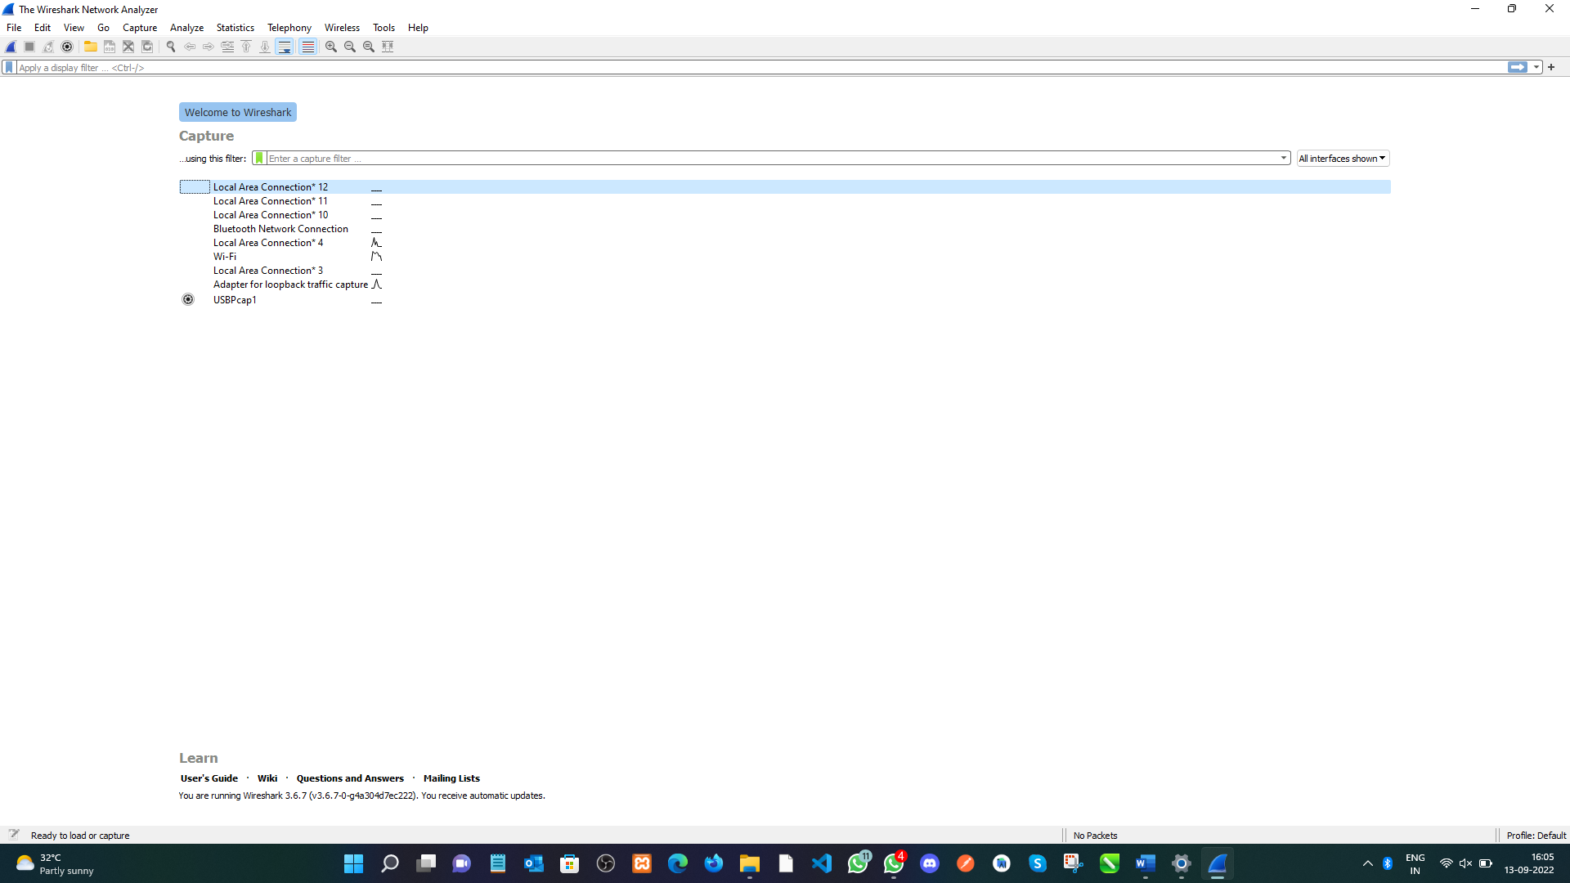

1. **Capturing the Protocols:**

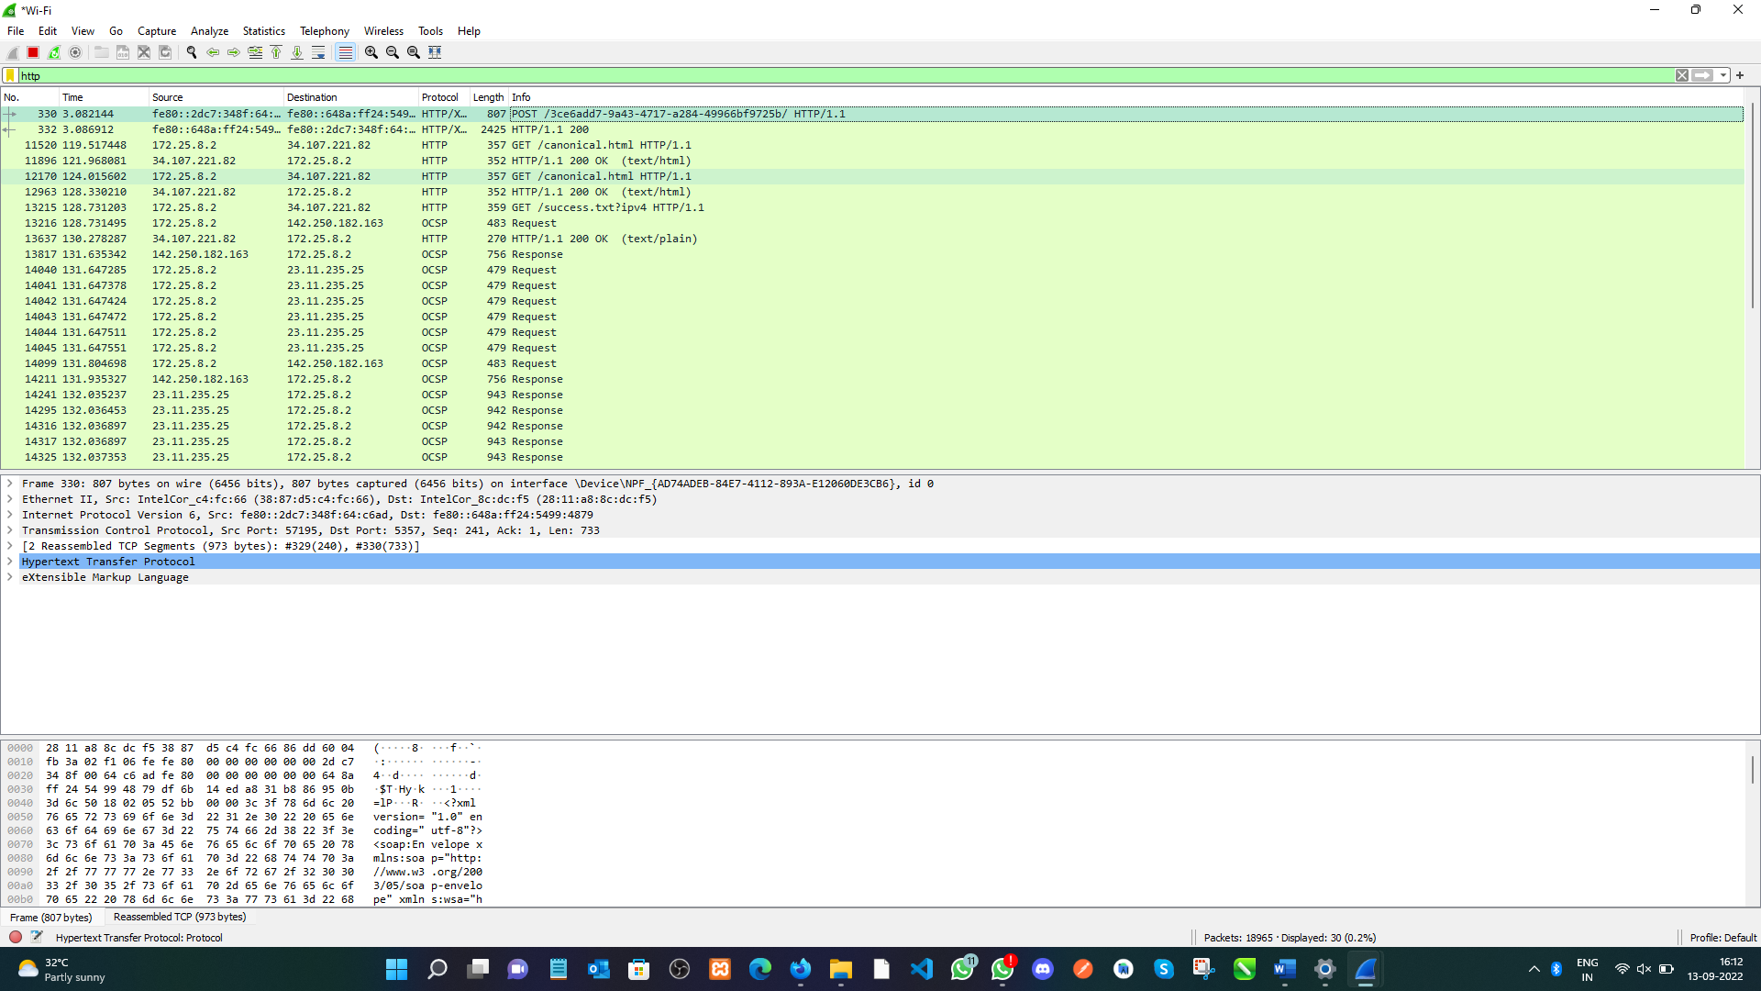

1. Analyze the Request URL

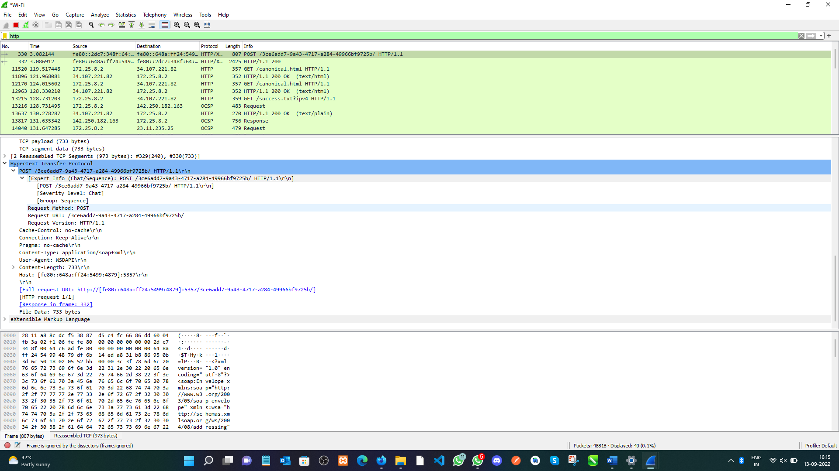

**5. Observations/Discussions/ Complexity Analysis:**

In this Experiment we have learn about the Wireshark software how to use and how it works. Using this we have see all over activities going on our network.

**Learning outcomes (What I have learnt):**

Identify requests (from the client) and response packets. Find HTTP version, response code/phrase, requested file (including size). Observe a single small file (e.g., a simple HTML file) request/response behaviour and the request/response behaviour for a file that has already been received. Observe how a larger file is sent in multiple segments Observe multi-file (e.g., a web page with an image) request/response behaviour. Observe request/response behaviour for a page that needs authentication.

**Evaluation Grid (To be created per the faculty's SOP and Assessment guidelines):**

|  |  |  |  |
| --- | --- | --- | --- |
| Sr. No. | Parameters | Marks Obtained | Maximum Marks |
| 1. | Worksheet completion including writing learning objectives/Outcomes.  (To be submitted at the end of the day). |  |  |
| 2. | Post-Lab Quiz Result. |  |  |
| 3. | Student Engagement in  Simulation/Demonstration/Performance and Controls/Pre-Lab Questions. |  |  |
|  | Signature of Faculty (with Date): | Total Marks Obtained: |  |